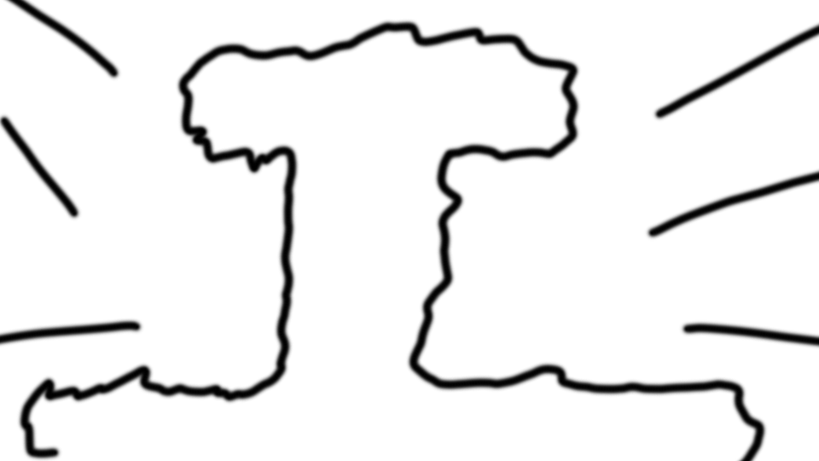

Video Game Design and Development

**LEVEL**

**Page**

**SHOT #**

# ACTION/DIALOGUE/EFFECTS/MUSIC

|  |
| --- |
| Shot #1 |
| Nuclear War |
| All the worlds major governments, militaries and civilzations are destroyed by global nuclear warfare. |
|  |
|  |
|  |
|  |
|  |
|  |
|  |

Video Game Design and Development

**LEVEL Page**

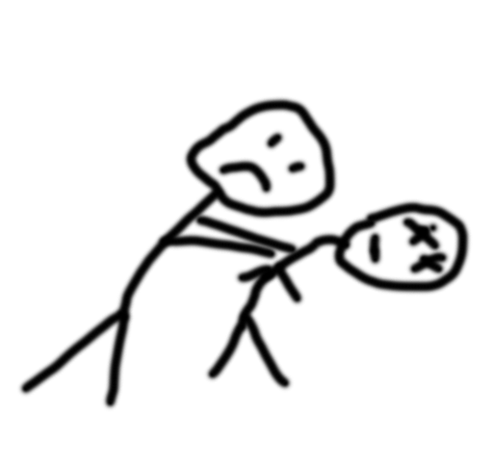**SHOT # SHOT #**

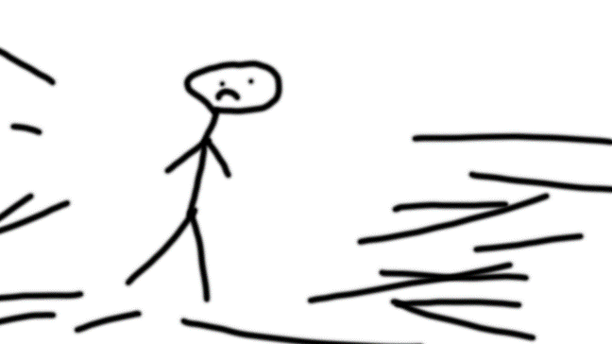

**ACTION ACTION**

**Shot #2 Shot #3**

**The world destroys the last of its resources People have nothing, and are tired of**

**In unrestricted local warefare. war. They are ready for a new way.**

**SHOT # SHOT #**

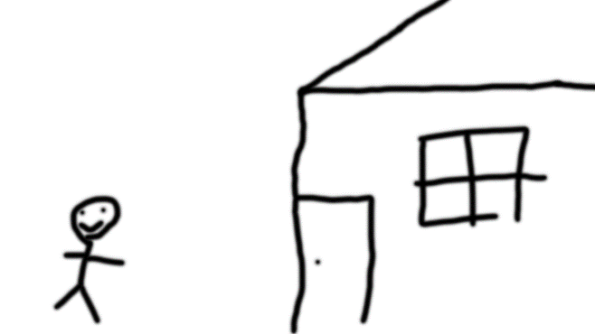

**ACTION ACTION**

**Shot #4 Shot #5**

**People turn away from war and start to You decide to use your resources and**

**regrow. knowledge to start rebuilding.**

**LEVEL Page**

**SHOT # SHOT #**

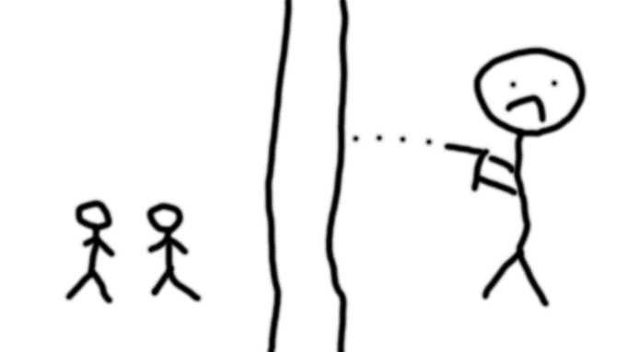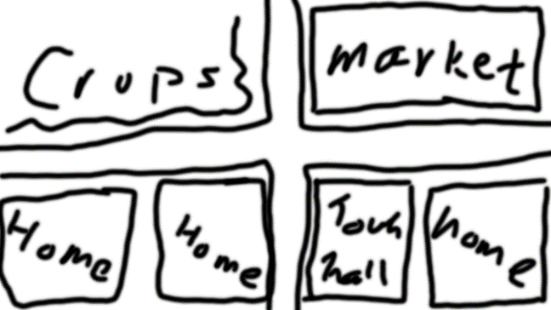

**ACTION ACTION**

**Shot #6 Shot # 7**

**Other people eagerly join you to help Barbarians attack and try to destroy**

**rebuild, and now towns re-emerge. what you have made.**

**SHOT # SHOT #**

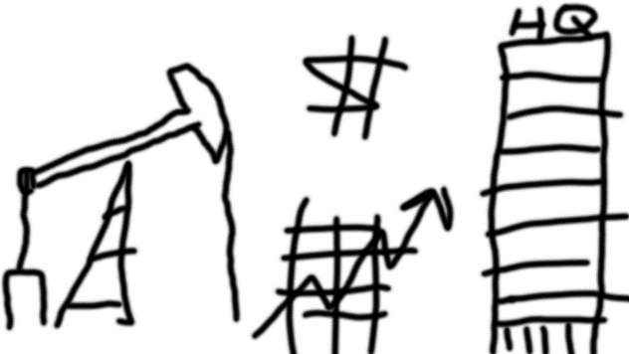

**ACTION ACTION**

**Shot # 8 Shot # 9**

**You build walls around your new towns From the safety provided by towns and**

**to protect them from barbarians. cities you are able to rebuild civilization**

**and grow your own company.**